**Mu Editor Installation - Step by Step**

**By Sanjeev Sapre**

(These steps are prepared for “Python for Teenagers” Course)

Document Last updated – 12-Apr-2020

Contents

Go to the download site 3

Install the editor. 3

Check if it was installed correctly. 8

# Go to the download site

<https://codewith.mu/en/download>

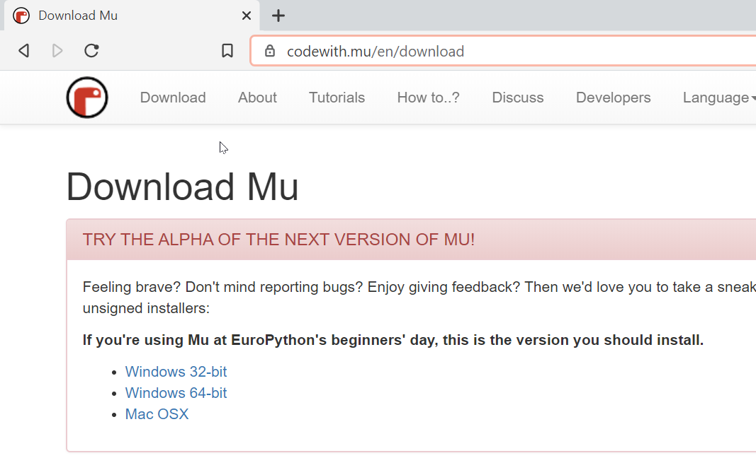

Click on Windows 32-bit , download the file

# Install the editor.

Double click the downloaded file and then follow these steps .

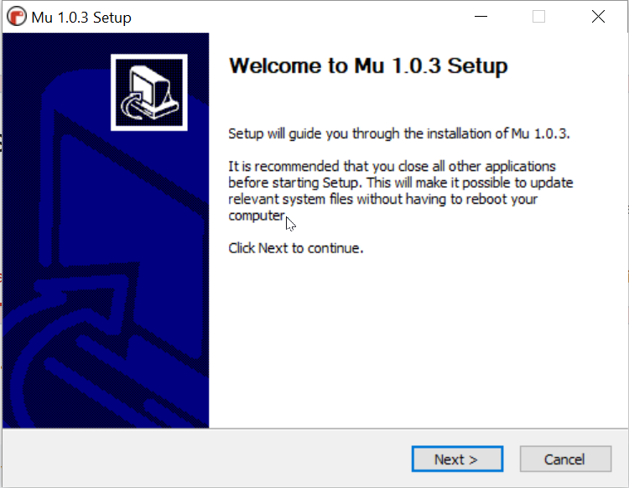

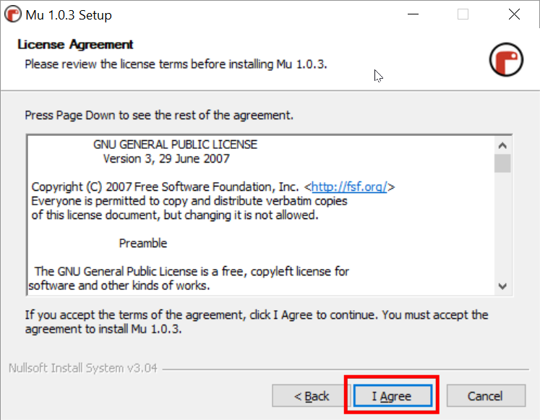

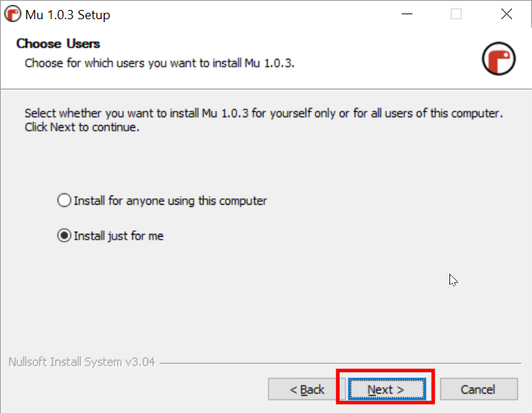

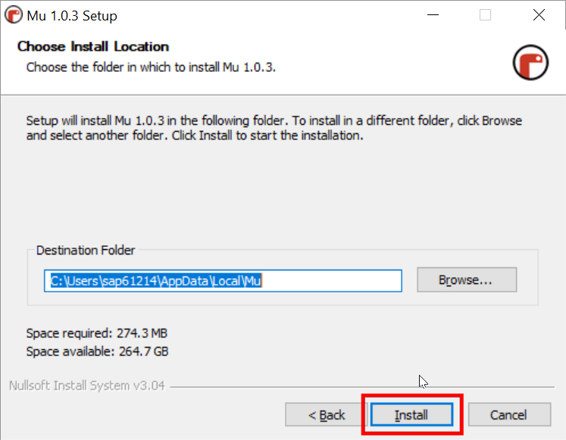

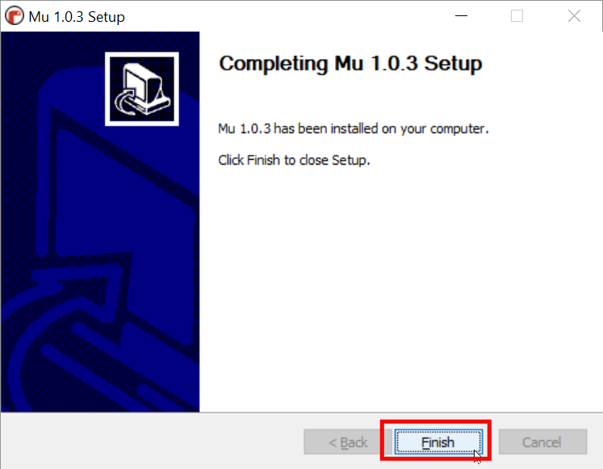

# Check if it was installed correctly.

Just to make sure that it is installed properly

Go to windows menu

Look for MU editor icon..

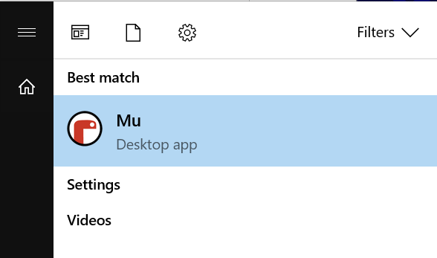

Click on and open

The editor should open, it should look like this.

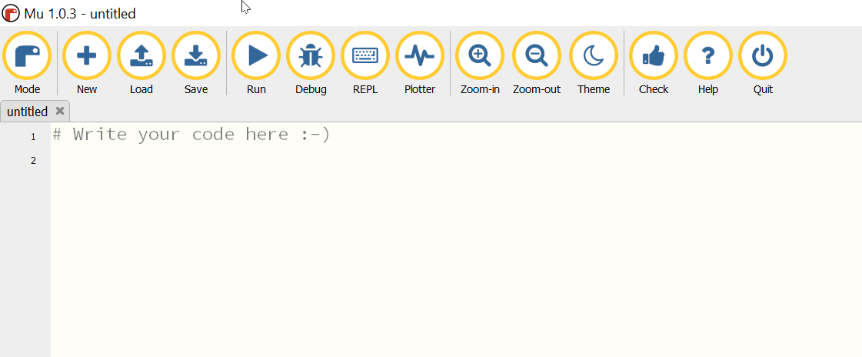

Congratulations .. you have successfully installed the editor.